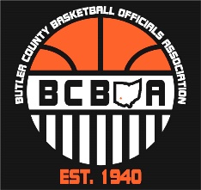
3rd BCBOA Meeting Agenda
October 28, 2024

Opening – Tim (5 min.)
BCBOA (whistles) give back gift/Jag’s Sporting Goods order forms
Items for Sale: BCBOA shirts, shorts & toboggins $10, sweatshirts $20 & whistles $5
Voting for: President, Vice President, Mechanics Interpreter & Member At-Large #1 will
be put on a google form. (Announce candidates)
Notes:
- Jeff sent out link to vote. Voting can happen through 11/3. Results will be announced during BCBOA meeting on 11/4
BCBOA Business – Brad (5 min.)
Treasurer Report $3281.13
Notes:
- Can pick up gift once Local Dues are paid
- Venmo for Local Association is @BCBOA
Talking from Observer POV – Randy Johnson (40 to 45 min.)
Notes:
- Hustle and effort(regardless of level)
- Don’t punish the defense
  - Watch the defense
  - Understand the principle of verticality
- Rules Knowledge, including proper verbiage
- Seek answers, seek knowledge, ask veterans
- Be patient with whistle. Don’t anticipate
- 25 Most misunderstood Rules -> posted on BCREF
- Take control of the game. Officiate during the dead ball periods

Closing of Meeting – Tim (5min.)
Any final comments (look for Voting email)

Next meeting is Tuesday, October 29, 2024 at 8pm
In the FHS Arena – enter thru door 8

