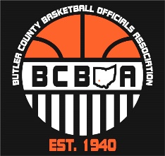
5th BCBOA Meeting Agenda
October 30, 2023
Opening – Tim (5 min.)
Election Results
Treasurer – Brad Short
Rules Interpreter Liaison – Rick Henry
Member At-Large #3 – Eric Higgins
BCBOA Business (5 min.)
- Tim Lewis made a motion to donate $100 to FHS for the use of their facilities for our meetings
- Rick Henry seconded the motion
- All present agreed
Concussion Protocol - Jeff (5 min.)
- Need to be Concussion certified every 3 years via the NFHSA concussion protocol training
- OHSAA Concussion Regulations - https://ohsaaweb.blob.core.windows.net/files/Sports-Medicine/ConcussionRegulations.pdf
Treasurer Report – Steve M. (5 min.)
- Can reach out to Steve to purchase any BCBOA gear
steve.meyer@lakotaonline.com
Rules/Mechanics – Rick and Brian (40 to 45 min.)
Discussion items - POE (rule changes) & videos
- Officiating professionalism and use of proper terminology
- Establishing pivot foot & traveling
- Legal guarding position, block/charge and verticality
- Loose ball recovery
- Went into videos of examples above
Closing of Meeting – Tim (5min.)
Any final comments
State meeting is due by Nov. 21st at11:59
Be on the lookout for 2 local online meetings from the state.

