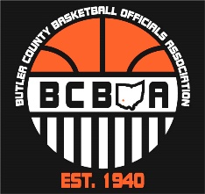
2nd BCBOA Meeting Agenda
October 16, 2023
Opening (welcome) – Tim (5min.)
Flemming’s Sporting Goods – Tim (5 min.)
BCBOA Website/Social Media overview & Dragonfly – Jeff (5 min.)
- Go to BCREF.com. A lot of information about leagues/assignors
- Twitter/X handle @BCBOA513
- BCBOA Facebook page. It’s private
  - Both Twitter/X and Facebook is a great tool to look and discus plays with other officials
BCBOA Business – Steve (5 min.)
Treasurer Report
- $2917.73
Nominations for: Treasurer, Rules Interpreter Liaison, Member At-Large #3
BCBOA (Beanies) – Gift give back
- Nominations for above BCBOA board seats are due by Friday October 20th
- Elections will be Next week
Rules/Mechanics – Rick and Brian (20 to 25 min.)
Discussion items - POE (rule changes) & videos
- Discussed update to Rules 7.5.2 thru 7.5.5, which talks about the 4 designated throw-in
- Discussed Rule 7.6 Which is when to correct a scenario where the ball was given to the wrong team. Clarified with State Rules director that time WILL NOT be put back on the clock
- Discuss addressing Bench Decorum by coaches and taunting of opposing players. State would like this to be addressed.
Closing of Meeting – Tim (5min.)
Any final comments (members for elections on 10/23)
Next meeting is Monday, October 23, 2023 at 7pm
In the Media Center

